**Q1. What is the benefit of regular expressions?**

Regular Expressions, also known as “regex” or “regexp”, are used to **match strings of text such as particular characters, words, or patterns of characters**. It means that we can match and extract any string pattern from the text with the help of regular expressions.

**Q2. Describe the difference between the effects of "(ab)c+" and "a(bc)+." Which of these, if any, is the unqualified pattern "abc+"?**

Both **(ab)c+** and **a(bc)+** are valid patterns. the difference between both these patterns is in **(ab)c+** **ab** is group whereas in **a(bc)+** **bc** is a group.

**Q3. How much do you need to use the following sentence while using regular expressions? import re**

**import re** statement always has to be imported before using regular expressions.

**Q4. Which characters have special significance in square brackets when expressing a range, and under what circumstances?**

The Characters **.,*,?,^**,or,**()**, have a special signiface when used with square brackets. They need not be be explicitly escaped by **\** as in case of pattern texts in a raw string.

**Q5. How does compiling a regular-expression object benefit you?**

We can Combine a regular expression pattern into pattern Objects.Which can be used for pattern matching. it also helps to search a pattern again without rewritting it.

**Q6. What are some examples of how to use the match object returned by re.match and re.search?**

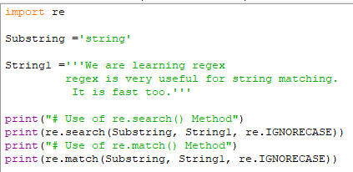

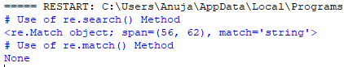

**Conclusion :**

1. **re.search()** is returning match object and implies that first match found at index 69.
2. **re.match()** is returning none because match exists in the second line of the string and re.match() only works if the match is found at the beginning of the string.
3. **re.IGNORECASE** is used to ignore the case sensitivity in the strings.
4. Both **re.search()** and **re.match()** returns only the first occurrence of a substring in the string and ignore others.

**Q7. What is the difference between using a vertical bar (|) as an alteration and using square brackets as a character set?**

When **|** us used then patterns searches for **or** option. i.e **<pattern_1>|<pattern_2>** means it searches as **<pattern_1>or<<pattern_2>** in the searched string. the first occurance of matched string will be returned as the Match Object. Using Character set in square Brackets searches for all the character set in the square bracket and if match is found, it returns it.

**Q8. In regular-expression search patterns, why is it necessary to use the raw-string indicator (r)? In   replacement strings?**

Raw Strings are used in the regular-expression search patterns, so that blackslashes donot have to be escaped.